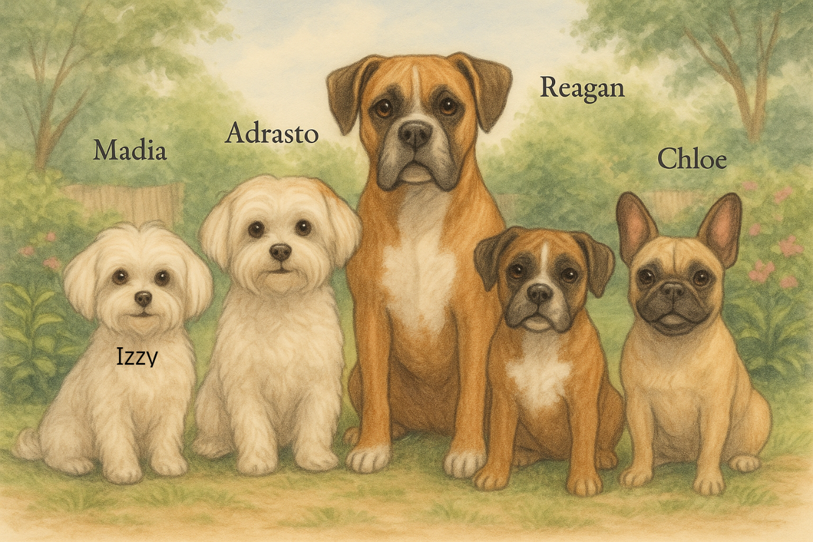

From Pawprints to Heaven’s Gate
Love from All Your Pups
Each wag, each woof, each quiet gaze,
Still wraps you in love across time and space.

Madia
Thank you for every gentle touch—I still feel them in heaven.
Izzy
You gave me the best life, and I carry your love with me always.
Adrasto
I guarded your heart then, and I still do now, from above.
Reagan
Your love made me brave, even in my final days.
Chloe
I’m still right here, tail wagging, loving you every single day.

